Name: ________________________________ Period: __________________________
Agriculture in the Fertile Crescent
By Ancient History Encyclopedia, adapted by Newsela staff on 08.01.17
Word Count 572
Level 950L
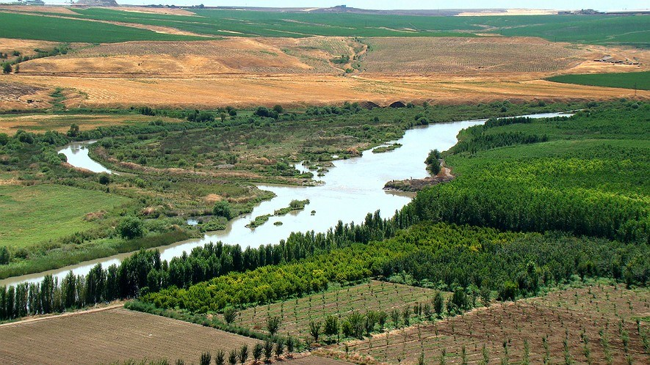
Roughly 100 kilometres from its source, the Tigris River is already an important river for agriculture just outside Diyarbakir, Turkey. Photo by: Bjørn Christian Tørrissen, from Wikipedia
1. The Fertile Crescent is in the region of the Middle East and Mediterranean Basin. Today it is the countries of Iraq, Syria, Lebanon, Cyprus, Jordan, Israel and the Palestinian areas and Egypt. Even parts of Turkey and Iran were in the Fertile Crescent.
2. This area is seen as the birthplace of agriculture. Seven thousand years ago, this area was not as dry as it is today. It was blessed with fertile soil, two great rivers (the Euphrates and the Tigris), and hills and mountains to the north.

Geography
3. The region produced a wide variety of crops. In very good years, up to 100 times more grain was harvested than in an average year. Many harvests were destroyed by drought or flooding. Artificial irrigation systems existed, but people preferred to rely on the rainy, hilly areas to ensure a more even spread of rainfall.
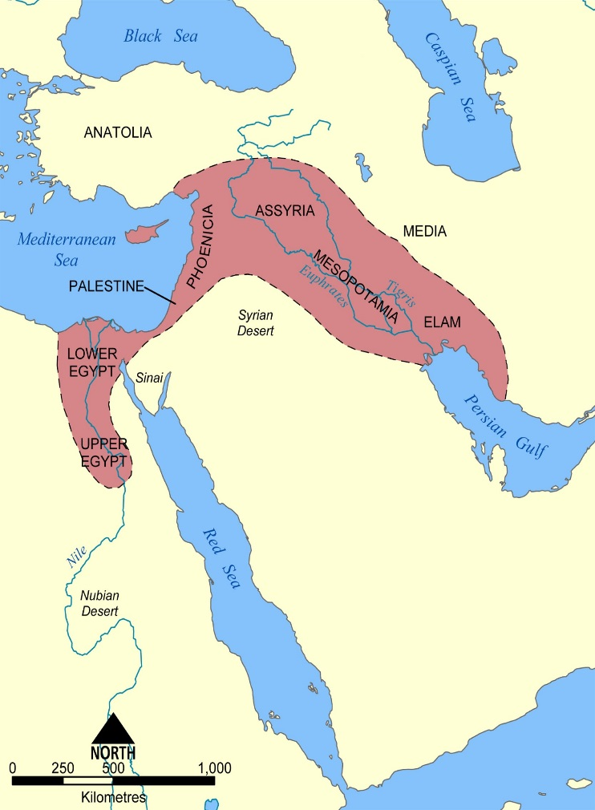
4. In the drier regions, agriculture was only possible with irrigation canals. The Urartians were the masters of canal building. Many of their irrigation systems still exist. The main canals were generally created and maintained by the state, and the small ones by the farmers themselves or the local communities. Irrigated farmland, as is still the case today, was under constant threat of salination. Irrigated water contains salt solids that can be left behind when the water evaporates. Salt can then build up to high levels that makes it more difficult for plants to get water from the soil. It may even kill the crops.
5. The soil, particularly in the flood plains of Babylonia and Assyria, often dried up, hardened and cracked. In order to keep the soil healthy, the plow had to be used. By 3000 B.C. plows were known and in wide use. Many Assyrian kings boasted of having invented a new, improved type of plow.

Crops
6. The main types of grain that were used for agriculture were wheat, barley and millet. Rye and oats were not yet known for agricultural use. In Babylonia, Assyria and the Hittite lands, barley was the main grain for human use: It was widely used to buy other goods, and flat bread was made from it. The smallest unit of weight was the equivalent of one grain (1/22 g). Beer and luxury foods were made from wheat.
7. Other agricultural products included sesame, which was widely cultivated and used to make oil. Olive oil was produced in the mountains. Flax was used to make linen cloth. Peas were cultivated in Mesopotamia, while lentils were preferred in Palestine. Figs, pomegranate, apple and pistachio groves were found throughout the Fertile Crescent. In villages and cities of southern Mesopotamia, groves of date palms were common. The dates were eaten either fresh or dried, and palm wood was also used in crafts, but not in construction.

Harvest and storage
8. Harvest required significant manpower, as there was immense time pressure to complete the harvest before winter set in. Grain was cut with a sickle, dried in shacks and threshed by driving animals over it to "tread out" the grain. This removed the husk from the grain. The grain was then either stored in granaries, or transported away along the waterways. Sometimes it was even exported to other countries. In the granaries, cats and mongooses were used to protect the stored grain from mice.

Comprehension Check:
- Read the section "Geography."
Select the sentence from the section that suggests that agricultural technology was a source of pride.
    - In very good years, up to 100 times more grain was harvested than in an average year.
    - Artificial irrigation systems existed, but people preferred to rely on the rainy, hilly areas to ensure a more even spread of rainfall.
    - The main canals were generally created and maintained by the state, and the small ones by the farmers themselves or the local communities.
    - Many Assyrian kings boasted of having invented a new, improved type of plow.
- Which paragraph from the section "Crops" or "Harvest and storage" supports the inference that places outside of the Fertile Crescent did NOT produce as much grain? Underline the words that support your inference.
- Read the sentence from the section "Geography."
Artificial irrigation systems existed, but people preferred to rely on the rainy, hilly areas to ensure a more even spread of rainfall.
Which of the following words, if it replaced the word "artificial" in the sentence above, would CHANGE the meaning of the sentence?
    - fictitious
    - unnatural
    - fabricated
    - manufactured

- Read the following sentence from the section "Harvest and storage." Then, fill in the blank.
Harvest required significant manpower, as there was immense time pressure to complete the harvest before winter set in.
The word "immense" in the sentence above tells the reader that ____.
  - the time pressure was boring
  - the time pressure was massive
  - the time pressure was shocking
  - the time pressure was never-ending

Answer Key
- Read the section "Geography."
Select the sentence from the section that suggests that agricultural technology was a source of pride.
    - In very good years, up to 100 times more grain was harvested than in an average year.
    - Artificial irrigation systems existed, but people preferred to rely on the rainy, hilly areas to ensure a more even spread of rainfall.
    - The main canals were generally created and maintained by the state, and the small ones by the farmers themselves or the local communities.
    - Many Assyrian kings boasted of having invented a new, improved type of plow.
- Which paragraph from the section "Crops" or "Harvest and storage" supports the inference that places outside of the Fertile Crescent did NOT produce as much grain?
Paragraph 8:
Harvest required significant manpower, as there was immense time pressure to complete the harvest before winter set in. Grain was cut with a sickle, dried in shacks and threshed by driving animals over it to "tread out" the grain. This removed the husk from the grain. The grain was then either stored in granaries, or transported away along the waterways. Sometimes it was even exported to other countries. In the granaries, cats and mongooses were used to protect the stored grain from mice.
- Read the sentence from the section "Geography."
Artificial irrigation systems existed, but people preferred to rely on the rainy, hilly areas to ensure a more even spread of rainfall.
Which of the following words, if it replaced the word "artificial" in the sentence above, would CHANGE the meaning of the sentence?
    - fictitious
    - unnatural
    - fabricated
    - manufactured
- Read the following sentence from the section "Harvest and storage." Then, fill in the blank.
Harvest required significant manpower, as there was immense time pressure to complete the harvest before winter set in.
The word "immense" in the sentence above tells the reader that ____.
  - the time pressure was boring
  - the time pressure was massive
  - the time pressure was shocking
  - the time pressure was never-ending

