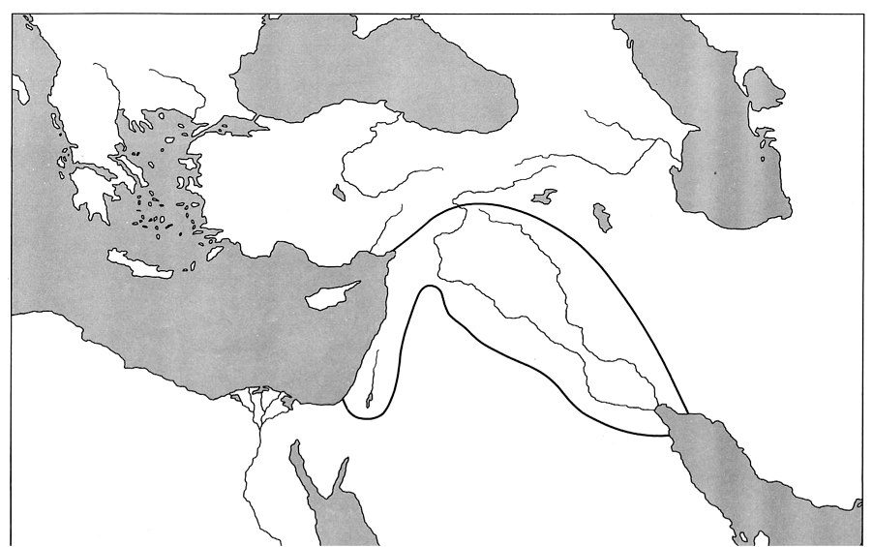
Social Studies: Geography of the Fertile Crescent Name:_______________________________ Period: _________
Title of this Map: ___________________________________________________________________________
Label the following, use the Holt Eastern World book:
Pg. 115: 1.The Mediterranean Sea, 2.The Persian Gulf, 3.The Euphrates River, 4.The Tigris River, 5.The cities of Tyre, Nineveh, Babyon, and Ur
Pg. 117: 6. The Taurus Mountains, 7. The Zagros Mountains, 8. Mesopotamia, 9. The Syrian Desert 10. The Nile River

