Name: __________________

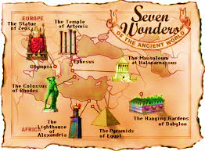

Use the readings and videos to determine how each wonder transformed society. Choose one of the world wonders and build a model of this wonder. Complete the attached World Wonder Information Sheet, using text evidence from this printout and the videos to assist you. If you wish, you may do extra research.

Ancient Wonder 1: Lighthouse of Alexandria
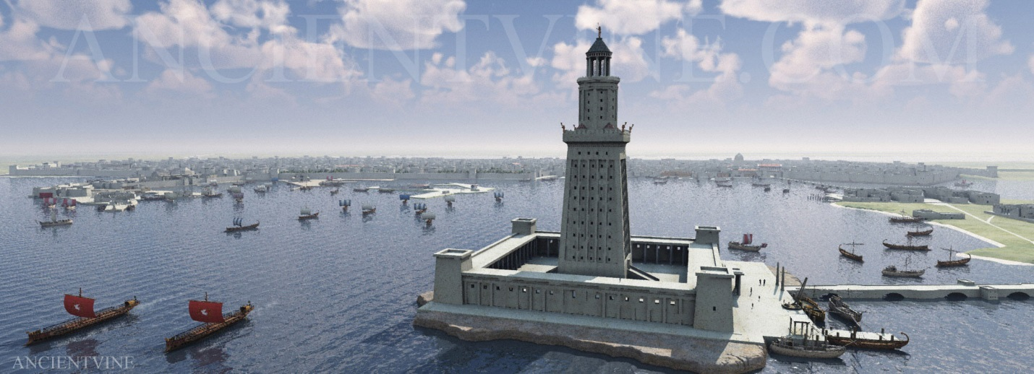
http://www.history.com/topics/ancient-history/sevens-wonders-of-the-ancient-world/videos/the-lighthouse-at-alexandria?m=528e394da93ae&s=undefined&f=1&free=false
- The Lighthouse of Alexandria was located on a small island called Pharos near the city of Alexandria. Designed by the Greek architect Sostratos and completed around 270 B.C. during the reign of Ptolemy II, the lighthouse helped to guide Nile River ships in and out of the city’s busy harbor. Archeologists have found ancient coins on which the lighthouse was depicted, and from them deduced that the structure had three tiers: a square level at the bottom, an octagonal level in the middle and a cylindrical top. Above that stood a 16-foot statue, most likely of Ptolemy II or Alexander the Great, for whom the city was named. Although estimates of the lighthouse’s height have ranged from 200 to 600 feet, most modern scholars believe it was about 380 feet tall. The lighthouse was gradually destroyed during a series of earthquakes from 956 to 1323. Some of its remains have since been discovered at the bottom of the Nile.

Ancient Wonder 2: Pyramid of Giza
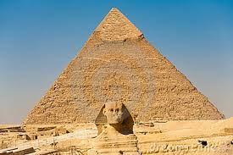
http://www.history.com/topics/ancient-history/sevens-wonders-of-the-ancient-world
- The Great Pyramids, located at Giza on the west bank of the Nile River north of Cairo, are the only wonder of the ancient world that has survived to the present day. The three pyramids–Khufu (Cheops), Khafra (Chephren) and Menkaura (Mycerimus)–were built between 2700 B.C. and 2500 B.C. as royal tombs. The largest and most impressive is Khufu, which covers 13 acres and is believed to contain more than 2 million stone blocks that weigh from two to 30 tons each. For more than 4,000 years, Khufu reigned as the tallest building in the world. In fact, it took modern man until the 19th century to build a taller structure. Amazingly, the nearly symmetrical pyramids were built without the aid of modern tools or surveying equipment. Scientists believe that the Egyptians used log rollers and sledges to move the stones into place. The sloped walls, which were intended to mimic the rays of Ra, the sun god, were originally built as steps, and then filled in with limestone. The interior of the pyramids included narrow corridors and hidden chambers in an unsuccessful attempt to foil grave robbers. Although modern archeologists have found some great treasures among the ruins, they believe most of what the pyramids once contained was looted within 250 years of their completion.

Ancient Wonder 3:- Hanging Garden of Babylon

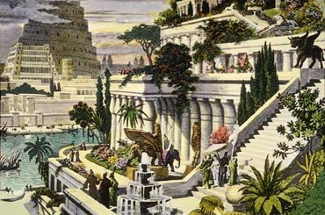
https://www.youtube.com/watch?v=Kfg1YE-BqTc
- According to ancient Greek poets, the Hanging Gardens of Babylon were built near the Euphrates River in modern-day Iraq by the Babylonian king Nebuchadrezzar II around 600 B.C. The gardens were said to have been planted as high as 75 feet in the air on a huge square brick terrace that was laid out in steps like a theater. The king allegedly built the towering gardens to ease his lover Amytis’ homesickness for the natural beauty of her home in Media (the northwestern part of modern-day Iran). Later writers described how people could walk underneath the beautiful gardens, which rested on tall stone columns. Modern scientists have deduced that for the gardens to survive they would have had to be irrigated using a system consisting of a pump, waterwheel and cisterns to carry water from the Euphrates many feet into the air. Though there are multiple accounts of the gardens in both Greek and Roman literature, none of them are first, and no mention of the gardens has been found in Babylonian cuneiform inscriptions. As a result, most modern scholars believe that the existence of the gardens was part of an inspired and widely believed but still fictional tale.

Ancient Wonder 4: Temple of Artemis at Ephesus
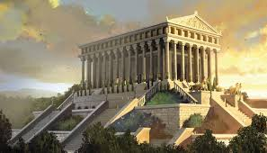
https://www.youtube.com/watch?v=eni3Xou9sVo
- There was actually more than one Temple of Artemis: A series of several altars and temples was destroyed and then restored on the same site in Ephesus, a Greek port city on the west coast of modern-day Turkey. The most fabulous of these structures were two marble temples built around 550 B.C. and 350 B.C., respectively. The former was designed by the Cretan architect Chersiphron and his son Metagenes and decorated by some of the most celebrated artists of the ancient world. The building burned on July 21, 356 B.C., according to legend the same night that Alexander the Great was born. About six years later, the building of a ew temple to replace it was begun. The new building was surrounded by marble steps that led to a more than 400-foot-long terrace. Inside stood 127 60-foot marble columns and a statue of Artemis. Archeologists disagree as to whether the building had an open-air ceiling or was topped with wood tiles. The temple was largely destroyed by Ostrogoths in A.D. 262, and it was not until the 1860s that archeologists dug up the first of the ruins of the temple’s columns at the bottom of the Cayster River.

Ancient Wonder 5: Mausoleum at Halicarnassus
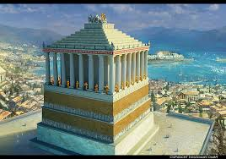
https://www.youtube.com/watch?v=v_JKrvetYuk
Located in what is now southeastern Turkey, the Mausoleum at Halicarnassus was a tomb built by Artemisia for her husband, Mausolus, the king of Carnia in Asia Minor, after his death in 353 B.C. Mausolus was also Artemisia’s brother, and, according to legend, she was so grief-stricken at his passing that she mixed his ashes with water and drank them in addition to ordering the mausoleum’s construction. The massive mausoleum was made entirely of white marble and is thought to have been about 135 feet high. The building’s complicated design, consisting of three rectangular layers, may have been an attempt to reconcile Lycian, Greek and Egyptian architectural styles. The first layer was a 60-foot base of steps, followed by a middle layer of 36 Ionic columns and a stepped, pyramid-shaped roof. At the very top of the roof lay the tomb, decorated by the work of four sculptors, and a 20-foot marble rendition of a four-horse chariot. The mausoleum was largely destroyed in an earthquake in the 13th century and its remains were later used in the fortification of a castle. In 1846, pieces of one of the mausoleum’s friezes were extracted from the castle and now reside, along with other relics from the Halicarnassus site, in London’s British Museum.

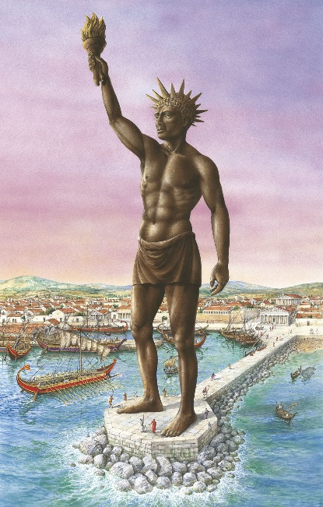
Ancient Wonder 6: Colossus of Rhodes
https://www.youtube.com/watch?v=M1_l0Xgt7Aw

The Colossus was an enormous bronze sculpture of the sun god Helios built by the Rhodians over 12 years in the third century B.C. The city was the target of a Macedonian siege early in the fourth century B.C. and, according to legend, the Rhodians sold the tools and equipment left behind by the Macedonians to pay for the Colossus. Designed by the sculptor Chares, the statue was, at 100 feet, the tallest of the ancient world. It was completed around 280 B.C. and stood for sixty years until it was toppled in an earthquake. It was never rebuilt. Hundreds of years later, Arabs invaded Rhodes and sold the remains of the statue as scrap metal. Because of this, archeologists do not know much about the exact location of the statue or what it looked like. Most believe that it depicted the sun god standing naked while he lifted a torch with one hand and held a spear in the other. It was once believed that the statue stood with one leg on each side of a harbor, but most scholars now agree that the statue’s legs were most likely built close together to support its immense weight.

Ancient Wonder 7: Zeus at Olympia
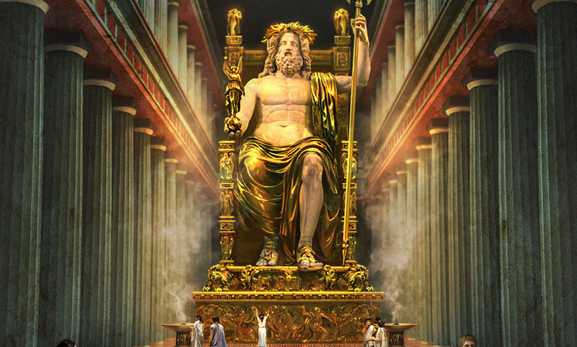
- https://www.youtube.com/watch?v=G18Jne7oO5g
The famed statue of Zeus was crafted by the Athenian sculptor Phidias and completed and placed in the temple of Zeus at Olympia, site of the ancient Olympics, around the mid-fifth century B.C. The statue depicted the god of thunder seated bare-chested at a wooden throne. Holding up the thrones’ armrests were two carved sphinxes, mythical creatures with the head and chest of a woman, the body of lion and the wings of a bird. The statue of Zeus was richly decorated with gold and ivory. At 40 feet, it was so tall that its head nearly touched the top of the temple. According to legend, the sculptor Phidias asked Zeus for a sign of his approval after finishing the statue; soon after, the temple was struck by lightning. The Zeus statue graced the temple at Olympia for more than eight centuries before Christian priests persuaded the Roman emperor to close the temple in the fourth century A.D. At that time, the statue was moved to a temple in Constantinople, where it is believed to have been destroyed in a fire in the year 462.

My Wonder of the World
Name: _________________________________________

Ancient Wonder chosen: ________________________
______________________________________________

Location: ______________________________________
Time Period:
Built in: _____________ Stood until: _______________
Who built this wonder? __________________________
Why? _________________________________________
Fun fact: ______________________________________

How did this wonder reflect the culture it represents? Use text evidence to support your answer

________________________________________________________________________________________________________________________________________________________________________________________

How did this wonder transform the society it represents? Use text evidence to support your answer

________________________________________________________________________________________________________________________________________________________________________________________

Use the readings and videos to determine how each wonder transformed society. Choose one of the world wonders and build a model of this wonder. Complete the attached World Wonder Information Sheet, using text evidence from this printout and the videos to assist you. If you wish, you may do extra research.

My Wonder of the World Rubric
Criteria | Possible Pts. | Pts. Received
Information Sheet (25 pts total)
- Sheet is complete and accurate | 5
- Reflection of culture supported with evidence | 10
- Transformation of society supported with evidence | 10
Model (25 pts total)
- Model is an accurate representation of the Ancient Wonder of the World | 15
- Neat, sturdy, and attractive | 5
- Creative use of resources | 5
Total Points Earned | 50

Project Description
Due Date: Monday, February 11. Points will be deducted for late work.

The Model
From the list of the 7 Wonders of the Ancient World, student is to choose one of the Wonders, and build a replica of it. The replica may be built out of whatever resources the student chooses – cardboard, Styrofoam, wood, paper, paint, found materials from around the house. For example, for either the Colossus of Rhodes or the Statue of Zeus, old action figures may be posed and painted, or if you are artistic molded out of clay; pyramids or temples may be built by stacking cardboard boxes (i.e. cereal boxes, cake mix boxes, etc.); columns may be made by rolling paper and topping with Styrofoam capstones and pedestals; and the light house might be made out of old cans that have been cleaned. The base of the project should not be larger than 18 x18 in. Creativity is one of the factors the student will be graded on. Let your artistic side loose!

The Information Sheet
Half of your grade will be based on your information sheet, which you received with this packet. You should start with the notes and video for your Ancient Wonder that you have received in class, but you may do additional research about your Wonder. You are required to use text evidence to support your answers. Evidence from the class work sheet may be cited as: (Classwork). Any other source should have a complete citation, and be included in your answer in parentheses. (Complete name of source)

