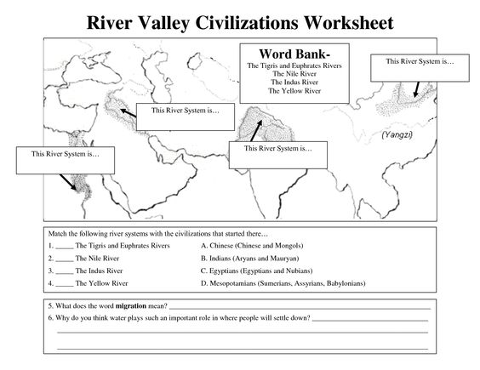
Social Studies Name: __________________________ Period: 1 2 3 4 5 6 7

